Factor B: Fullness
Factor A:  Weight |  | Empty | Full
 | Normal | n=20  T=440  SS=1540 | n=20  =15  T=300  SS=1270
 | Obese | n=20  = 17  T=340  SS=1320 | n=20  = 18  T=360  SS=1266
G=1440
N=80

- weight의 변화(2가지,normal,obese)에 따른 number of crackers eaten의 차이
H1: weight의 변화에 따른 number of crackers eaten의 차이가 있을 것이다.
H0: weight의 변화에 따른 number of crackers eaten의 차이가 없을 것이다.

- fullness의 변화(2가지,empty,full)에 따른 number of crackers eaten의 차이
H1: fullness의 변화에 따른 number of crackers eaten의 차이가 있을 것이다.
H0: fullness의 변화에 따른 number of crackers eaten의 차이가 없을 것이다.

- H1: weight와 fullness의 상호작용에 따른 number of crackers eaten의 차이가 있을 것이다.
H0: weight와 fullness의 상호작용에 따른 number of crackers eaten의 차이가 없을 것이다.
1.= N-1= 80-1=79
2.= N-k=80-4=76
3.= k-1=4-1=3
4.= number of levels of a – 1=2-1=1
5.= number of levels of b -1 =2-1=1
6.=dfbetween-dfa-dfb=3-1-1=1

SS
- =31836-(80*324)=5916
2.=∑SS each group=1540+1270+1320+1266=5396
1.=SS total-SS within=5916-5396=520
1.=∑(TA^2/ nA )– G^2/N = (740^2)/40 + (700^2)/40 -(1440^2)/80=13690+12250-25920=20
2.=∑(TB^2/ nB )– G^2/N=(780^2)/40 + (660^2)/40 – (1440^2)/80 = 15210+10890-25920=180
3.=SSbetween-SSA-SSB=520-20-180=320
MS
- =SSA/dfA=20/1=20
- =SSB/dfB=180/1=180
- =SSAXB/dfAXB=320/1=320
- =SSwithin/dfwithin=5396/76=71
F-ratio
- =MSA/MSwithin = 20/71=0.2817
- =MSB/ MSwithin = 180/71=2.5352
- =MSAXB/ MSwithin = 320/71=4.5070

 | Table 1. Mean number of crackers eaten in each treatment condition
 |  |  |  |  |  | Fullness
 |  |  |  |  |  | Empty  stomach |  |  | Full  stomach
 | Weight | Normal |  |  |  | M= 22  SD= 9.00 |  |  | M= 15  SD= 8.18
 |  | Obese |  |  |  | M= 17  SD= 8.34 |  |  | M= 18  SD= 8.16
Result
Source |  |  | SS | df | MS |  | F
Between treatment |  |  | 520 | 3
- Factor A (weight) |  |  | 20 | 1 | 20 |  | 0.28
- Factor B (fullness) |  |  | 180 | 1 | 180 |  | 2.53
- A x B interaction |  |  | 320 | 1 | 320 |  | 4.50
Within treatment |  |  | 5396 | 76 | 71
Total |  |  | 5916 | 79
weigth x fullness factorial

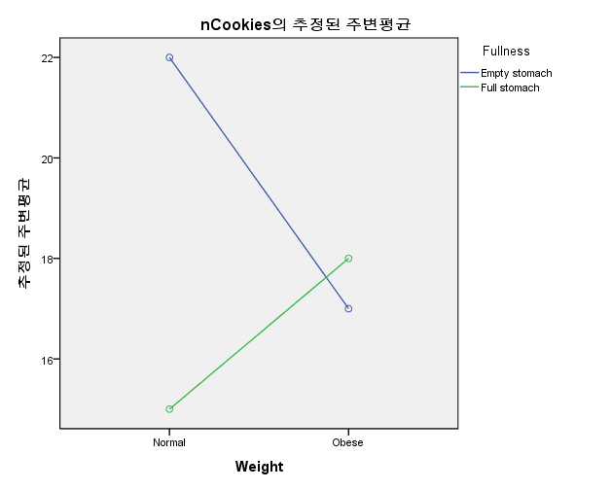
Weight와 numbers of cracker eaten는 상관관계가 없다. (F(1,71)=0.2817, p>.05) Fullness와 numbers of cracker eaten는 상관관계가 없다. (F(1,71)=2.5352, p>.05) 그리고 Weight와 fullness의 상호작용에 따른 number of crackers eaten는 상관관계가 있을 것이다. (F(1,71)=4.5070, p<.05)
따라서, weight와 fullness의 상호작용에 따른 number of crackers eaten라는 가설은 통계적으로 유의미하다.

