Factorial ANOVA의 예1을 완전히 풀어서 제시하시오.

step 1. Build hypotheses
①Weight에 따라 number of crackers eaten에 차이가 있을 것이다()
②Fullness에 따라 number of crackers eaten에 차이가 있을 것이다()
③Fullness와 Weight의 상호작용에 따라 number of crackers eaten에 차이가 있을 것이다
(H1: Weight팩터와 Fullness팩터 간의 상호작용이 존재한다. 즉, 각각의 상태에 따라서 나타나는 평균의 차이가 두 팩터가 갖는 주효과에 의해서만 설명되지 않고 부가적으로 더 있다.)

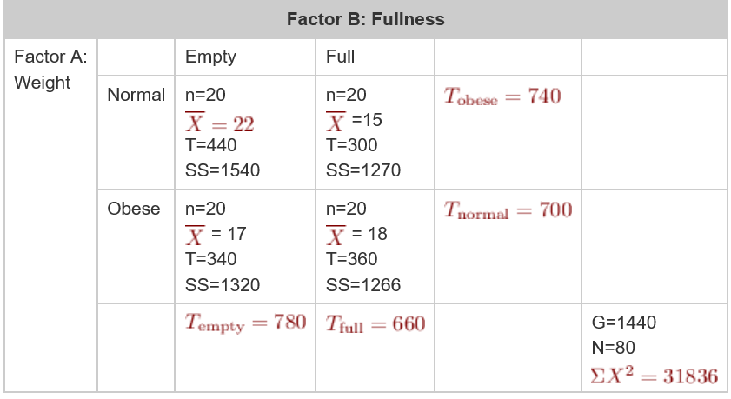

step 2. Locate the critical range for F-ratio. calculate the
= 20 + 20 + 20 + 20 – 1 = 79
= (20-1) + (20-1) + (20-1) + (20-1) = 76
= 4 – 1 = 3
= number of levels of A – 1 = 2 – 1 = 1
= number of levels of B – 1 = 2 – 1 = 1
- = df(between) – df(A) – df(B)
= 3 – 1 -1 = 1

Compute F-ratio SS
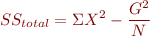 = 31836 – 1440^2 / 80
= 31836 – 25920
= 5916

- = SS(total) – SS(within) = 5916 – 5396 = 520
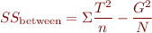 = 440^2/20 + 300^2/20 + 340^2/20 + 360^2/20 – 1440^2/80 = 9680 + 4500 + 5780 + 6480 – 25920 = 520

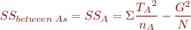 = (440+300)^2/40 + (340+360)^2/40 – 25920 = 13690 + 12250 – 25920 = 20
- = (440+340)^2/40 + (300+360)^2/40 – 25920
= 15210 + 10890 – 25920
= 180
= 520 – 20 – 180
= 320

MS
- = SS(A) / df(A) = 20/1 = 20
- = SS(B) / df(B) = 180/1 = 180
- = SS(A*B) / df(A*B) = 320/1 = 320
- = SS(within) / df(within) = 5396/76 = 71
F-ratio
- (1,76) = MS(A) / MS(within) = 20/71 = 0.2817
- (1,76) = MS(B) / MS(within) = 180/71 = 2.5352
- (1,76) = MS(A*B) / MS(within) = 320 / 71 = 4.5070
F(crit)(1,76) = 4.00
F(crit)(1,76) = 4.00
F(crit)(1,76) = 4.00

In the literature (APA style)
The means and standard deviations are presented in Table 1. The two-factor analysis of variance showed no significant main effect for the weight factor, F(1,71)= 0.2817, p>.05; and no significant main effect for the fullness factor, F(1,71)= 2.5352, p>.05; but the interaction between weight and fullness was significant, F(1,71)= 4.5070, p<.05.

Make decision
①Weight에 따라 number of crackers eaten에 차이가 없다
②Fullness에 따라 number of crackers eaten에 차이가 없다
③Fullness와 Weight의 상호작용에 따라 number of crackers eaten에 차이가 있다

Result
Source | SS | df | MS | F
Between treatment | 520 | 3
- Factor A (weight) | 20 | 1 | 20 | 0.2817
- Factor B (fullness) | 180 | 1 | 180 | 2.5352
- A x B interaction | 320 | 1 | 320 | 4.5070
Within treatment | 5396 | 76 | 71
Total | 5916 | 79
weigth x fullness factorial design

